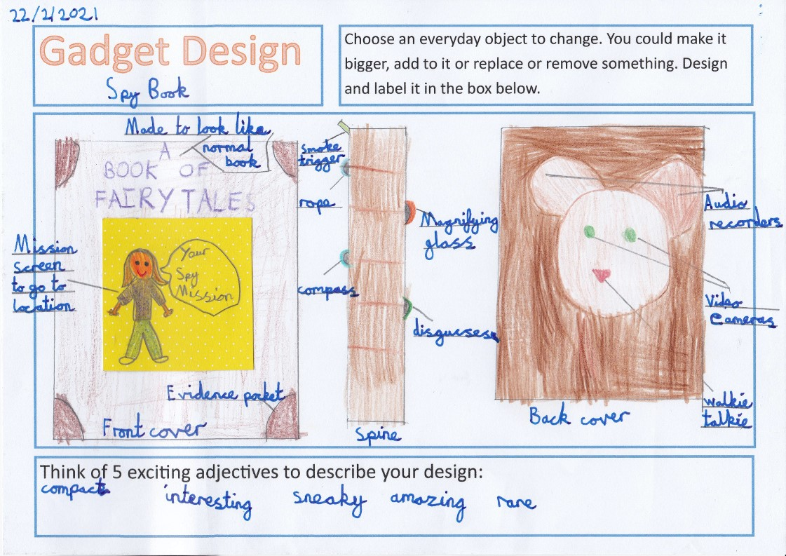

By Elva Green

By Freya Prince